Part a

It seems like a lot of the data is missing, and it's inconsistent on what's missing.

I chose age and impressions for the variables. I'm going to remove the rows

in which the age is 0, since that's not possible.

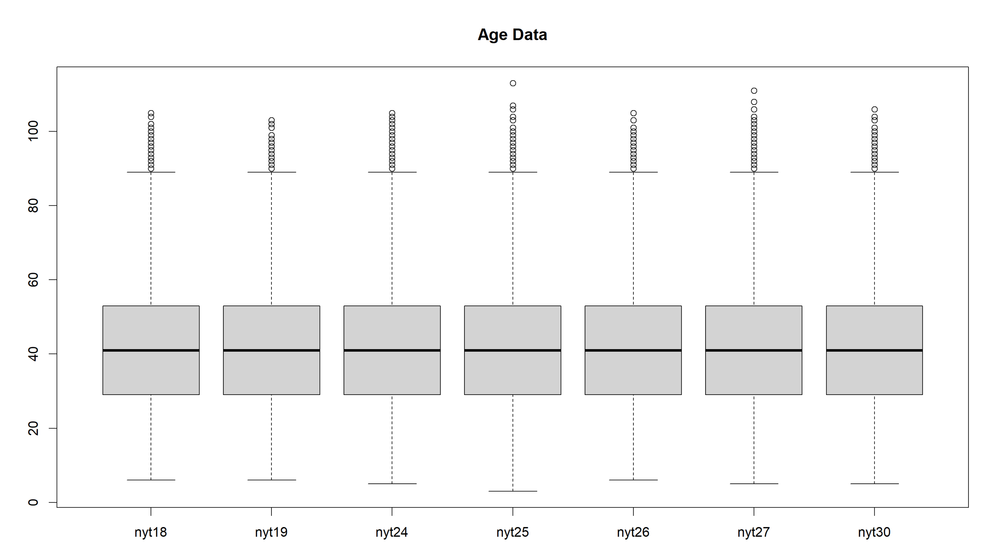

Discussion:

In both cases, it seems like the data has the exact same distribution across all nyt datasets.

I actually thought that this might've been because I removed the rows with 0s, but I did it

without removing those rows and they still all had the same distribution. Honestly it seems

like all these nyt datasets came from one main dataset and each individual one was randomly

sampled from the main one without replacement, they're so perfectly similar.

Part b

After experimenting, using 40 breaks seems to show a pattern without being too hard to see.

I also forced the x and y axis so show all numbers.

Discussion:

Regarding the age, yet again we see the exact same pattern emerge. All the datasets have

essentially the exact same distribution. However, it's worth noting that for some reason

nyt27 (my 6) has a little less than double the amount of data of the other data sets.

This is true even without removing the 0 rows, so I don't know why it's so much bigger.

The distribution skews right slightly and has a spiked pattern. Skewing right makes sense

as the older you are the you'll probably use nyt less, but I can't think of a reason

that ages 25ish, 35ish, and 45ish would use it less than other neighbors.

Regarding the Impressions, they all yet again have essentially the same distribution.

Ignoring the total num row differences, it seems to be a relatively gaussian curve, however

a little skewed to the right.

Part c

I also plotted the ecdf of a normal distribution for visual comparison:

Get a normal distribution of each and qqplot against that

As this takes a while to compute and I wasn't asked to do this for each dataset

I'm just going to use one of the datasets.

For Age:

For Impressions:

Discussion:

Of course, when doing the ecdf all the graphs look the same. Moving past that,

I've realized that this data is almost certainly not normal. From looking

at the ecdf of the variables, it's close but is slightly more linear. This is

made even more clear when we make the qqplot. The middle is almost perfectly

normal, however once we leave around 2 quantiles in either direction it gets

decisively less normal. It seems that in both variables the data gets more spread

out. This reminds me now more of a Cauchy distribution.

Part d

I want to use a Shapiro-wilks test for this, but that only works on sample sizes up to 5000.

Start of discussion: While doing research for this, I found out that most normality testing is useless

when it comes to very large sample sizes like this one since once you get large it's

basically guaranteed that our data will deviate from the idealistic normal distribution.

To demonstrate this, I'm going to do the Shapiro-wilks test on increasingly

larger samples from the data.

Sample size = 50

Sample size = 500

Sample size = 5000

Discussion Continued:

As we can see, the test gets increasingly confident that the data does not

follow a normal distribution as the number of samples we pull from it goes up.

Therefore, I don't believe that we can really say for sure whether or not

the data follows a normal distribution. Or rather, we should say that since the

data set is large it does not follow a normal distribution.

It is worth noting that it fails to have a normal distribution even on a small

sample, but I still believe that using normally tests on data of this size isn't

very effective. Visualizing with the qqplot is probably the best we'll get, and

there I saw that it likely wasn't normal (at least to my eye), so that's my conclusion.

This seems to not be normally distributed and we fail to reject the null hypothesis.